Program is complete and average accuracy of all 5 folds for “plant.wsd” is 98.92

Please find the below accuracies for all folds along with the average of accuracies for all 5 folds.

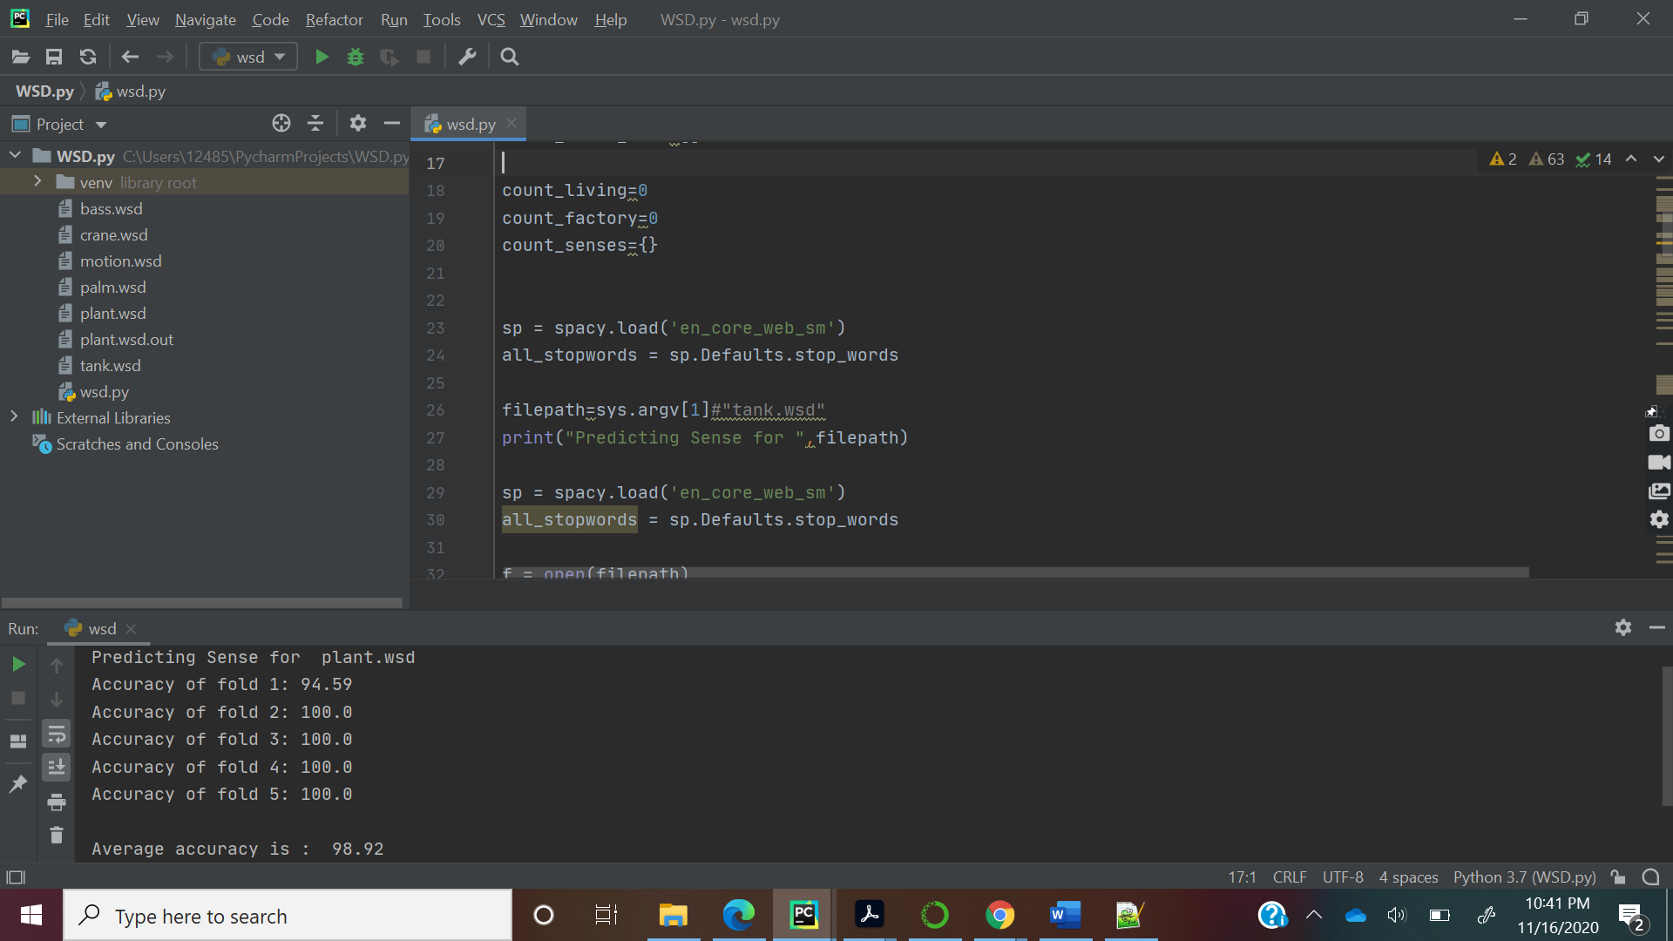

*<instance id="plant.1000036" docsrc = "BNC/A4J">*

*<answer instance="plant.1000036" senseid="plant%factory"/>*

*<context>*

*But her wider life was anything but solitary. Immensely learned about all aspects of modern Irish life, she knew almost everybody and was known to them. Perhaps the number of thinly-disguised character studies in modern fiction, from Molly Keane to Emma Tennant, are a better tribute to her than anything else, not all of them flattering, it must be said. She was an excellent shrewd local politician and a comfort to her at the end of her life was the defeat of the atrocious plans of the Merrell Dow Chemical Company to build a <head>plant</head> near her beloved River Blackwater, the last campaign in which she played an active part.*

*</context>*

*</instance>*

* **For the above instance, plant it predicted as living as this context contains River, Backwater. As these words contribute more to living than factory. This problem can be overcome by using a large set.**

*<instance id="plant.1000019" docsrc = "BNC/A29">*

*<answer instance="plant.1000019" senseid="plant%factory"/>*

*<context>*

*He introduced new boilers in the boilerhouse under the main galleries; he installed a completely new steel structure in the ceiling above the entrance hall without harming the ceiling paintings by Benjamin West and Angelica Kauffmann; he rebuilt the goods lift to carry loads of up to three tonnes into the galleries; he refurbished the public cloakrooms. More recently, he relocated the Schools Canteen from dingy basement to gleaming mezzanine and at the time of his death had nearly completed his greatest coup. This is an ingenious and unique method, devised with Professor Pat O'Sullivan, of environmental tuning in the great Victorian galleries. Rather than imposing artificial conditions, Serjeant allied Victorian engineering to twentieth-century control systems: he deployed the forces of natural convection, rather than cumbersome, mechanically-powered <head>plant</head> , to ensure a regulated flow of humidified and heated air through the galleries.*

*</context>*

*</instance>*

* **For the above instance, plant it predicted as living as this context contains *humidified*, *heated air*. As these words contribute more to living than factory. This problem can be overcome by using a large set.**

Program is complete and average accuracy of all 5 folds for “bass.wsd” is 78.1

Please find the below accuracies for all folds along with the average of accuracies for all 5 folds.

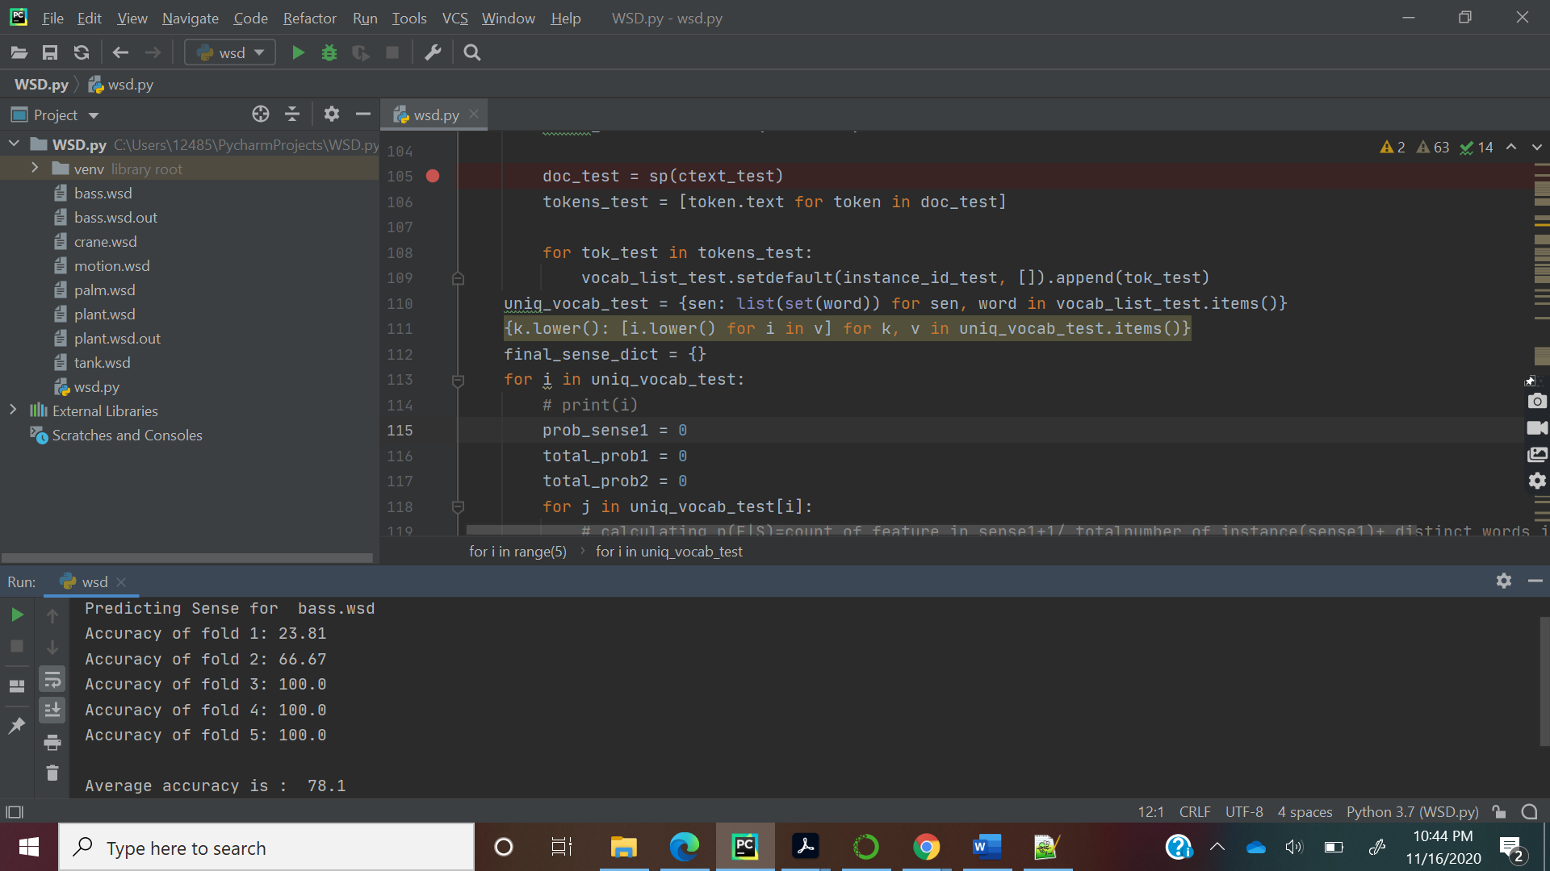

Program is complete and average accuracy of all 5 folds for “crane.wsd” is 86.32

Please find the below accuracies for all folds along with the average of accuracies for all 5 folds.

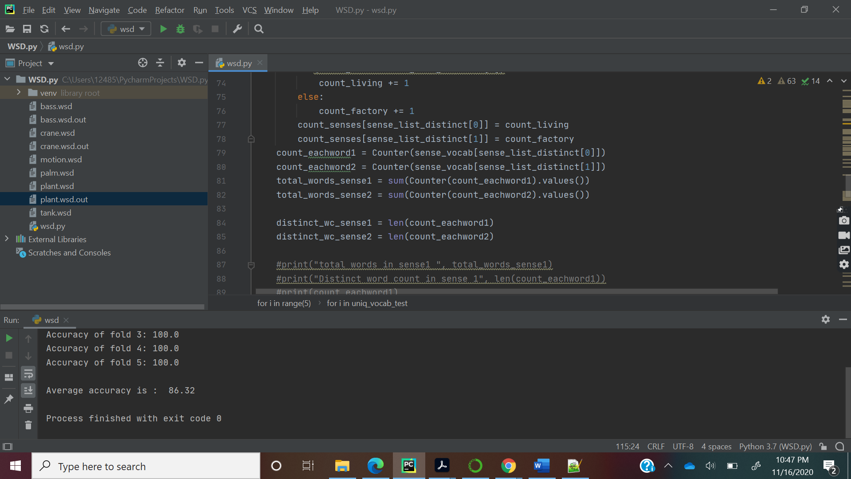

Program is complete and average accuracy of all 5 folds for “motion.wsd” is 90.00

Please find the below accuracies for all folds along with the average of accuracies for all 5 folds.

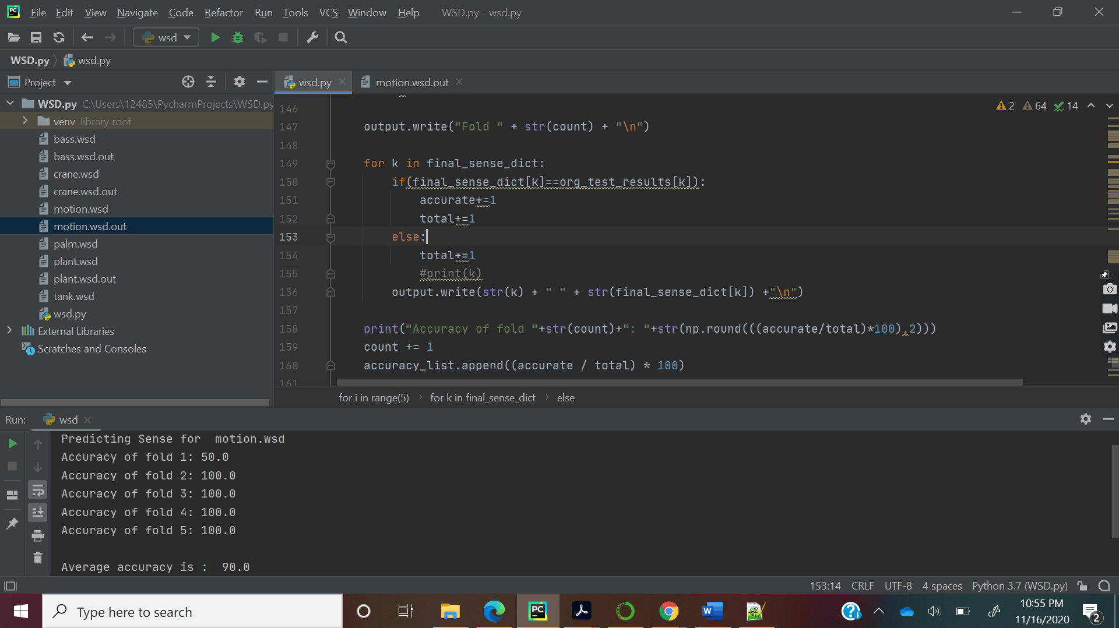

Program is complete and average accuracy of all 5 folds for “palm.wsd” is 94.0

Please find the below accuracies for all folds along with the average of accuracies for all 5 folds.

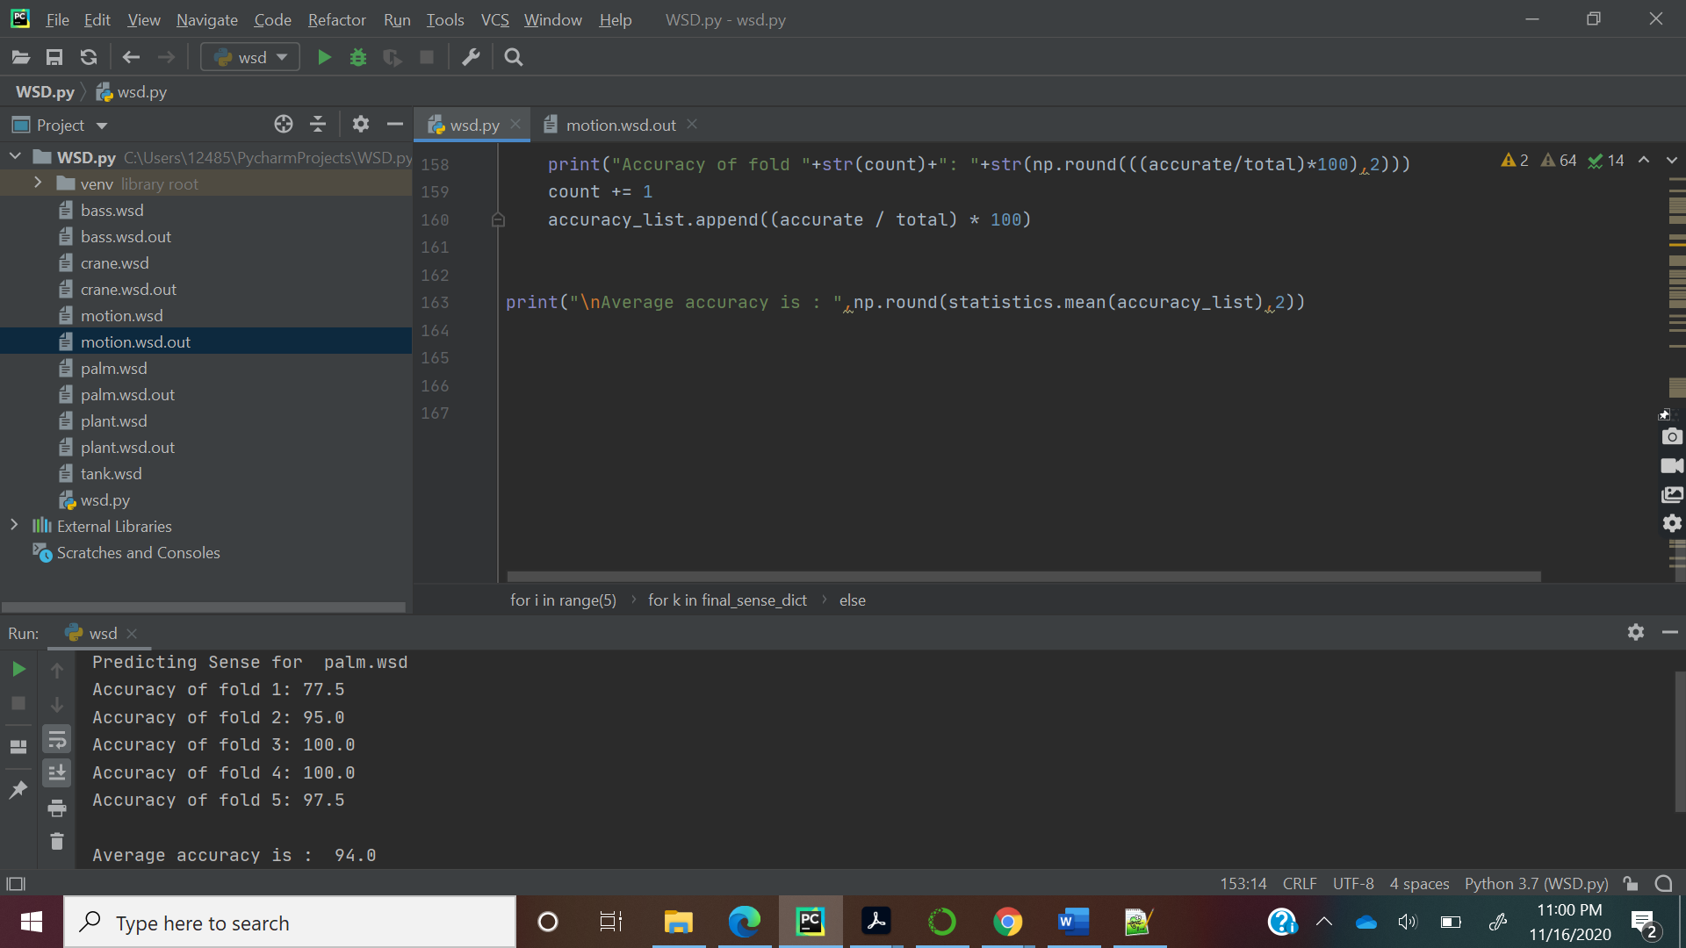

Program is complete and average accuracy of all 5 folds for “tank.wsd” is 94.0

Please find the below accuracies for all folds along with the average of accuracies for all 5 folds.

